**STIX Project Fonts**

# These are the fonts that were chosen for the STIX project. These are Google fonts so that they will be universally accessible.

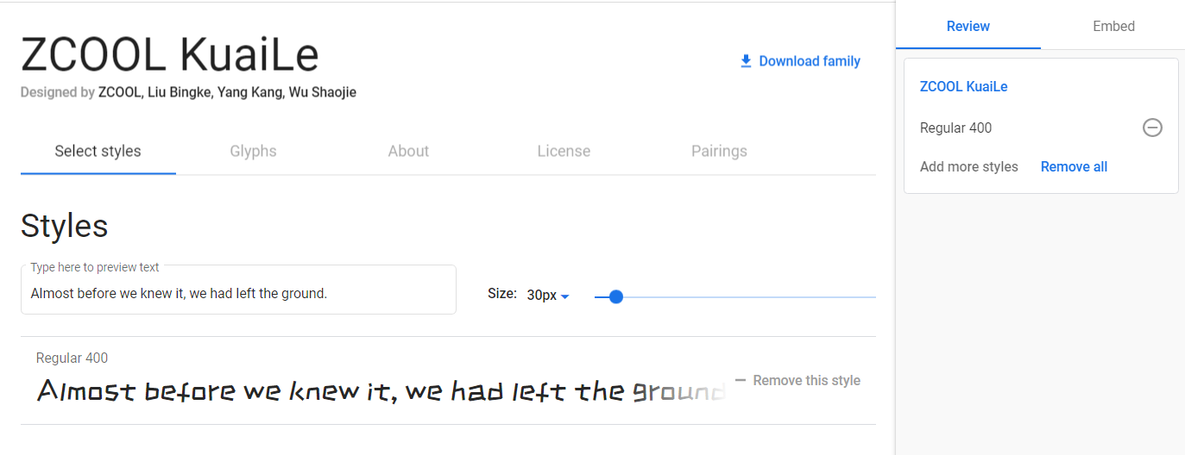

The first font is mainly for the heading and will be used for the name “STIX”. The google code for this font is as follows…

<link href="https://fonts.googleapis.com/css2?family=ZCOOL+KuaiLe&display=swap" rel="stylesheet">

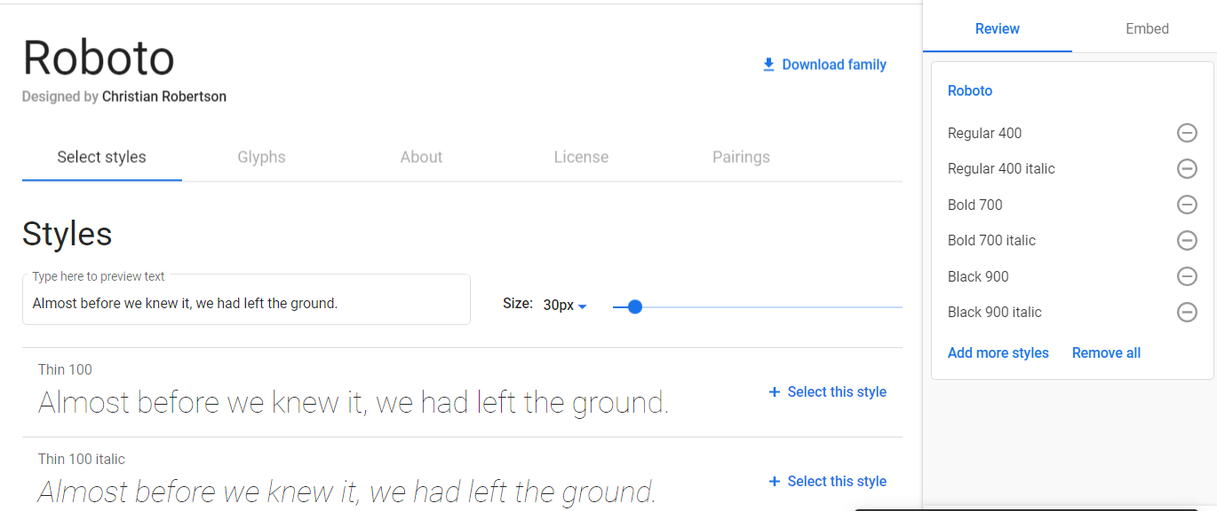

The next font is the Roboto font that will be used throughout the application as the default font. The google code for this font is as follows…

<link href="https://fonts.googleapis.com/css2?family=Roboto:ital,wght@0,400;0,700;0,900;1,400&display=swap" rel="stylesheet">

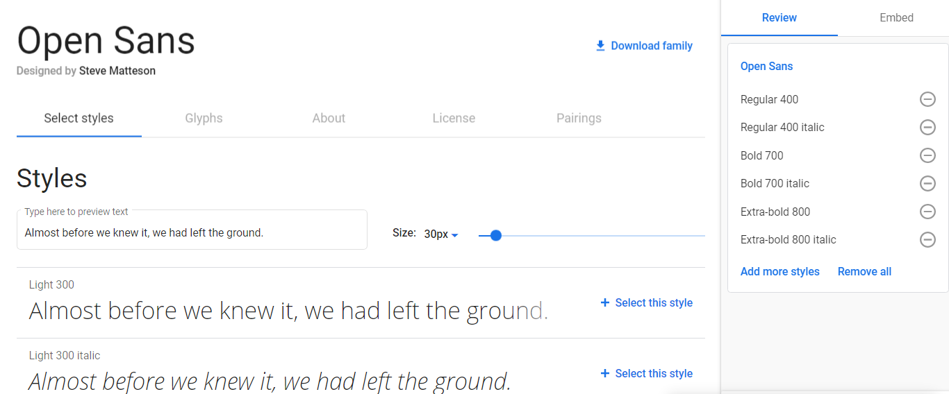

This is the 3rd font chosen for the project. It is a standard default font available in all browsers. This is the catch-all font for the project.

<link href="https://fonts.googleapis.com/css2?family=Open+Sans:ital,wght@0,400;0,700;0,800;1,400;1,700&display=swap" rel="stylesheet">